September 20, 2016

Dear Parents

There is a lot of learning going on in room 103. Each day brings so many surprising moments that inspire learning and fun. We are establishing our routines and are learning to work together as a team. It is surprising how little the children rely on names when they interact. I realized today that the children may know a friend’s favorite snack or favorite color, but they are still learning names.

The big event ahead is our UNIDOP which will be held on Friday, September 30th. For those of you who may be overwhelmed with all of the acronyms here at SCIS, UNIDOP stands for United Nations International Day of Peace. Basically, you will need to think about what clothes your child will wear to represent their home country and what delicious food you will contribute to our food celebration on that day. If you don’t have access to your country’s traditional clothes, then your son or daughter may want to wear your country’s flag colors. This is also a great way to show pride. If your child will not be present at school on this day, please let me know.

We have been working our way through the alphabet by reading stories with characters whose names begin with certain letters we are studying. I am aware that some children are able to identify all of the letters and sounds and that there are some who are new to phonics. Using stories to highlight letters sounds is a strategy I use so that everyone benefits. By engaging in shared reading, we are building our vocabularies and well as the skills needed for reading and writing. The children are excited about reading and writing and have begun to attempt to spell words phonetically. Please encourage them to write sounds for words and do not over emphasize correct spellings. If we send a message that they must use correct spellings at this stage, the writers will experience a “block” or inability to express their thoughts. My goal for them, as emerging writers, is that they will be able to communicate their thoughts freely. If they learn to spell phonetically, they can develop the most important writing skill and that is fluency. This does not mean to hover over them and to force them to spell out every word. If we are doing this, then they are not that engaged in the thinking that occurs in writing. This skill to spell phonetically will develop as they acquire a more proficient understanding of letters and their sounds. The spelling accuracy will evolve later. I will speak more about this during our parent conferences later in the year.

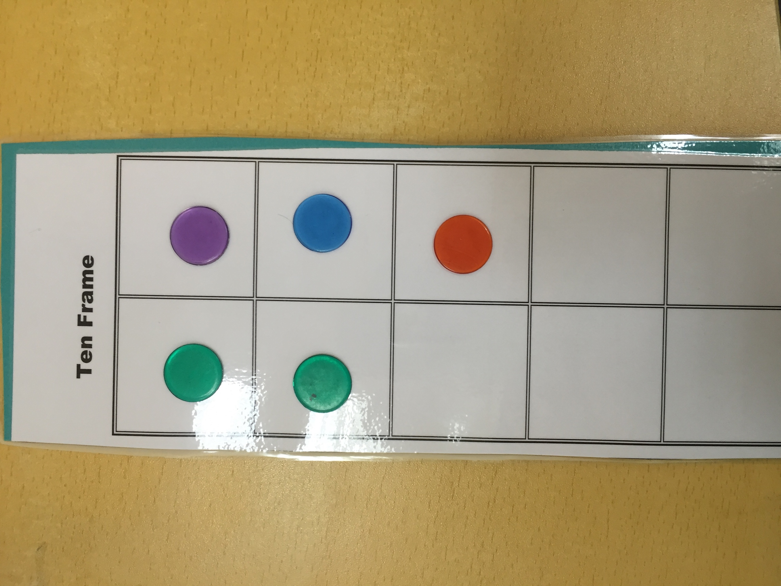

What is a TEN FRAME? It is a close friend of ours in KL! Building “number sense” is a critical part of understanding mathematics in kindergarten. Our math lessons have been built upon working with ten frames and decomposing ten into smaller groups. We show our understanding of the value of numbers to 10 by drawing in our math journal and sharing discussions around objects in our small groups. Being able to count to 10 and beyond is like singing a song. It’s easy once you learn the patterns. But don’t be fooled. It is more important to understand what you are singing and to be able to explain your thinking. Our math journals allow for differentiation and encourage the children to show what they know and understand.

I hope you are all able to catch the wealth of information by flowing on our class’ WeChat group. I’ve enjoyed sharing photos and videos and find that it is a timely way to spread the news!

As always, I am available to talk to you about your child’s progress on most days after school and sometimes during the school day. Contact me if you would like to set up a time to talk.

Best Regards,

Laurie

